Practice TAsk 2 REPORT

«Parametric linear voltage regulator»

**Principles of Circuits**

Student: CAO Xinyang 20321308

Program of Computer Science and Technology

group CS

Name Surname

# Work purpose: to study parameters of parametric linear voltage regulator

Goals:

1) Calculate parameters of Parametric linear voltage regulator

2) [Optional] Find transistor and Zenner diode corresponding to the requirements

# Starting data

* **Source voltage amplitude, [V] $V_{S}=$** 35
* **Voltage ripple [V]: ${ΔV}_{S}=$**  1
* **Voltage required on the load [V]: $V_{OUT}=$**  30.5
* **Load resistance, [Ω]: $R_{L}=$**  110
* **Base-emitter voltage [V]: $V_{BE}=$**  0.7
* **Minimum current to be maintained through the Zener diode [mA]: $I_{Z_{min}}=$**  2
* **Forward current gain of the transistor (IC/IB):**  110

# Calculations

1. Calculate load current

$I_{L}=\frac{V_{out}}{R_{L}}=$ 0.277 [A]

1. Define required stabilized voltage

+ 31.2 [V]

1. [optional] Choose the transistor according to the requirements:

$V_{CE_max}={(1.5 …2)V}_{in_max}=$ 72 [V]

$I_{C_max}>2I_{L}=$ 0.554 [A]

1. Choose $R_{v}$ is selected based on the condition that current $\left(1.5 …2\right)I_{z}$ should flow through the transistor at a minimum input voltage

$R_{vmax}=\frac{V_{in_{min}-}V_{Z}}{\left(1.5\right)I_{z}+\frac{V_{out}}{R_{L}\left(1+h_{FE}\right)}}=\frac{V_{Rv_{min}}}{\left(1.5\right)I_{z}+I_{B}}=$ 509.28 $[Ω]$

$R_{vmin}=\frac{V_{in_{min}-}V_{Z}}{\left(2\right)I_{z}+\frac{V_{out}}{R_{L}\left(1+h_{FE}\right)}}=\frac{V_{Rv_{min}}}{\left(2\right)I_{z}+I_{B}}=430.90$ $[Ω]$

1. Choose $R_{v}$ correspondingly to E24 Series of standard resistor values.

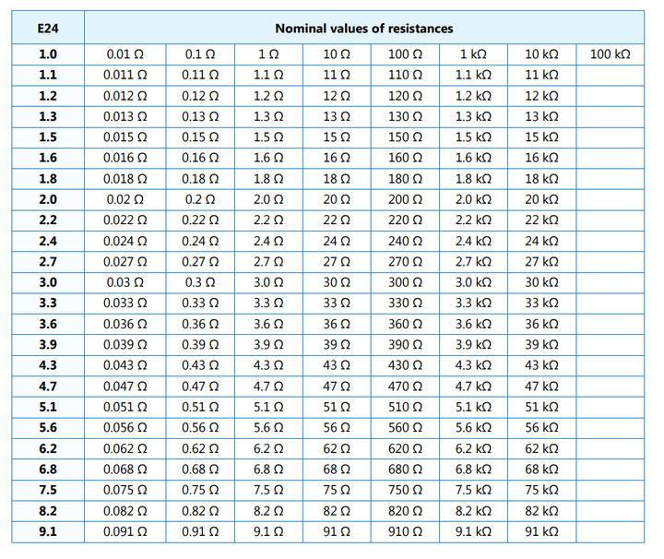

$R_{vmin}{<R}_{vE24}= 470 <R_{vmax}$ $[Ω]$

# Conclusions

Conclusions should contain:

1. Value of

470

2) [Optional] Which transistor correspond to the required parameters? Try to find one.